International Information Technology University

Coursework

Educational platform for programming courses

Done by: Sattibay G., Tazhben A., Beybarys A.

Checked by: Sarsembayev A.

Almaty 2020

Content

1. Introduction(User story).................................................................................. 2
2. Relevant Survey.............................................................................................. 4
3. Planning and task assigning ........................................................................... 5
4. Overview of competitors ................................................................................ 6
5. RESEARCHAPPROACHES **…**.................................................................... 9
6. What are we done for today? ......................................................................... 10
7. Architecture .................................................................................................... 11
8. Site map ......................................................................................................... 12
9. Conclusion ..................................................................................................... 14

Introduction(User story)

* We founded courses and in the process of teaching we had problems with:
  + **Lack** of convenience for **checking homework**
  + **Inconvenient structure in teaching** for students when send all material to the messengers(telegram , whatapp)
  + The **time limit** for the broadcast
  + **Expensive subscription** of similar online platform

After all of these, we wanted to solve this problem for ourselves

Build a platform that will be convenient for **users and business customers**

Will build a safe and fast system with **userFriendly** interface

Target audience

* The service will be used by students of our courses

Relevant Survey

54 graduates were interviewed

23 students (43%) are not satisfied with the ease of access to materials. Difficult to find or not find the right material The course materials were in the Telegram chat. They were thrown off as messages. Materials: lectures in text format, disassembled codes in the classroom, additional videos from teachers, useful links.

29 students (54%) are not satisfied with the technical quality of online classes. Due to the fact that streaming services were loaded for a long time, there were delays in the introduction of classes

Planning and task assigning

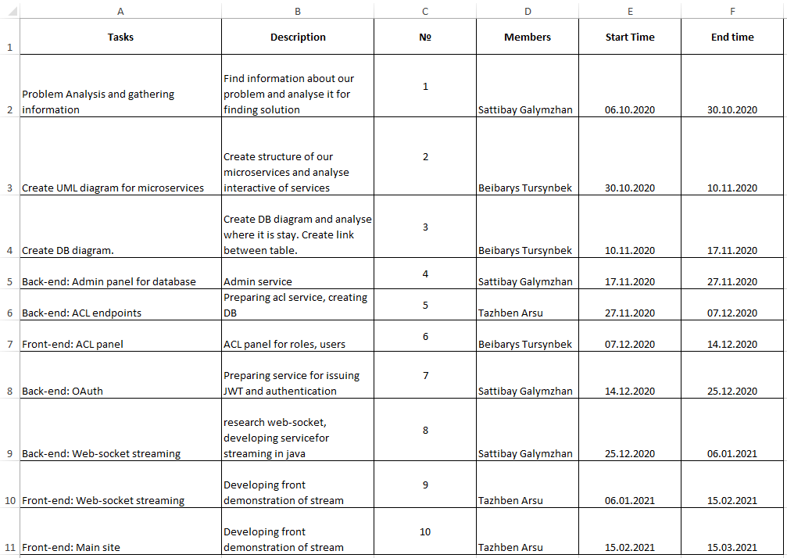

Overview of competitors

PLATFORMS

|  |  |
| --- | --- |
| CenturyTech | It offers a full range of courses based on microlearning in order to address knowledge gaps, challenge students and support the development of long-term memory. |
| ClassDojo | Ensures the connection between teachers, students and parents, building class communities |
| Edmodo | It provides tools and resources for managing courses and involving distance  learners, offering a variety of languages |
| Edraak | Represents a non-profit open online course portal for promoting knowledge in the Arab world. It is considered the first non-profit, pan-Arabic online educational platform to offer free courses to students around the world |
| EkStep | Open learning platform with a collection of learning resources to support literacy  and numbering |
| Google Classroom | Helps classes connect remotely, communicate and be permanently organized. |
| Moodle | Open, community-based learning platform supported worldwide. |
| Nafham | Arab language online learning platform hosting lessons of educational video films that correspond to Egyptian and Syrian school curricula |
| Paper Airplanes | Suitable for learners with personal tutors, promoting learning through sessions  (12-16 weeks) conducted via video conferencing platforms |
| Schoology | Offers tools that support instruction, learning, grading, collaboration and  evaluation. |
| Seesaw | Provides tools that enables and encourage the creation of collaborative and  sharable digital learning content. |
| Skooler | Provides tools aimed to turn Microsoft Office software into an educational  platform. |

Overview of the benchmarking criteria

|  |  |  |  |
| --- | --- | --- | --- |
| Functional Facilities that Enhance Active and Collaborative Learning | | | |
| CRITERIA | FAIR (5) | GOOD (8) | EXCELLENT (10) |
| Content  authoring | Provides basic means for content uploading and storing. | It allows the uploading, creation and storage of content by basic means in a creative system that is part of the platform. | Provides a suite of built-in tools that cand be used for creating rich media  content (audio, podcasts, videos, presentations, etc.). |
| Communication | Offers basic  communication facilities such as comments based on educational content or  basic messaging facilities. | Offers extensive means of communication such as real-time chat or  written/audio/video one-to-one communication  through tools that are part of the platform. | Offers complex means of  communication integrated  into the platform, such as video conferencing with a  large number of users. |
| Content transfer | Provides means for  instructors to exchange  educational content with students. | Offers extensive means by which educational content  can be transferred both  from the instructors to the students and from the students to the instructors. | Provides complex means  by which the educational  content can be exchanged  between all participants in  the educational process, including among learners. |
| Integration with  other platforms  that support  collaboration | The integration with  platforms or plugins that support written  communication such as e-mail or those used for  collaborative creation of educational content such as Google Docs is  ensured or possible | Integration with platforms that support both written collaboration and  extended video or audio  such as Google Meets or Zoom is ensured or  possible. | The integration with  platforms that support  both written, video and audio collaboration, as well as the distribution of  knowledge at external  level, such as platforms such as social networks is  ensured or possible. |
| Testing and  evaluation tools | Offers built-in basic  individual evaluation  tools for written  assessment, such as  questionnaires and open-  ended questions, or  students have the  opportunity to upload  materials in a variety of  formats using external  software tools. | Offers built-in basic  individual and  collaborative evaluation  tools for written  assessment, such as  questionnaires and open-ended questions, or students have the  opportunity to upload  materials in a variety of  formats using external  software tools | Offers built-in individual  and collaborative  assessment tools through  which students can solve tasks in writing, video or audio. |

Summary of the Results Obtained

|  |  |  |  |  |  |  |
| --- | --- | --- | --- | --- | --- | --- |
| PLATFORMS | Content creation | Communication | Content transfer | Integration with other platforms that support collaboration | Testing and evaluation tools | Total |
| ClassDojo | Good (8) | Fair (5) | Excellent (10) | Good (8) | Excellent (10) | 41 |
| Edmodo | Fair (5) | Good (10) | Excellent (10) | Good (8) | Excellent (10) | 43 |
| EkStep | Excellent (10) | Fair (5) | Excellent (10) | Good (8) | Fair (5) | 38 |
| Google  Classroom | Good (8) | Fair (5) | Excellent (10) | Good (8) | Good (8) | 39 |
| Moodle | Fair (5) | Good (8) | Excellent (10) | Good (8) | Good (8) | 39 |
| Schoology | Fair (5) | Good (8) | Excellent (10) | Good (8) | Good (8) | 39 |
| Seesaw | Excellent (10) | Fair (5) | Good (8) | Good (8) | Excellent (10) | 41 |
| Skooler | Good (8) | Fair (5) | Good (8) | Good (8) | Fair (5) | 34 |

**RESEARCH APPROACHES:**

We assume that our project uses both Quantitative / Qualitative.

Because the design of our competitors will be very difficult for us to evaluate in Quantitative. This part we will use when check for example speed. While qualitative we will use when check design or etc.All of the functionality proceed from basic because all of the function that we want to use we take from the competitor comparison. From take all the comparison we create particular idea.

What are we done for today?

Finished the full landing page.

Created relationships between tables and microservices

Link for our page: <http://fibonacci-school.kz/>

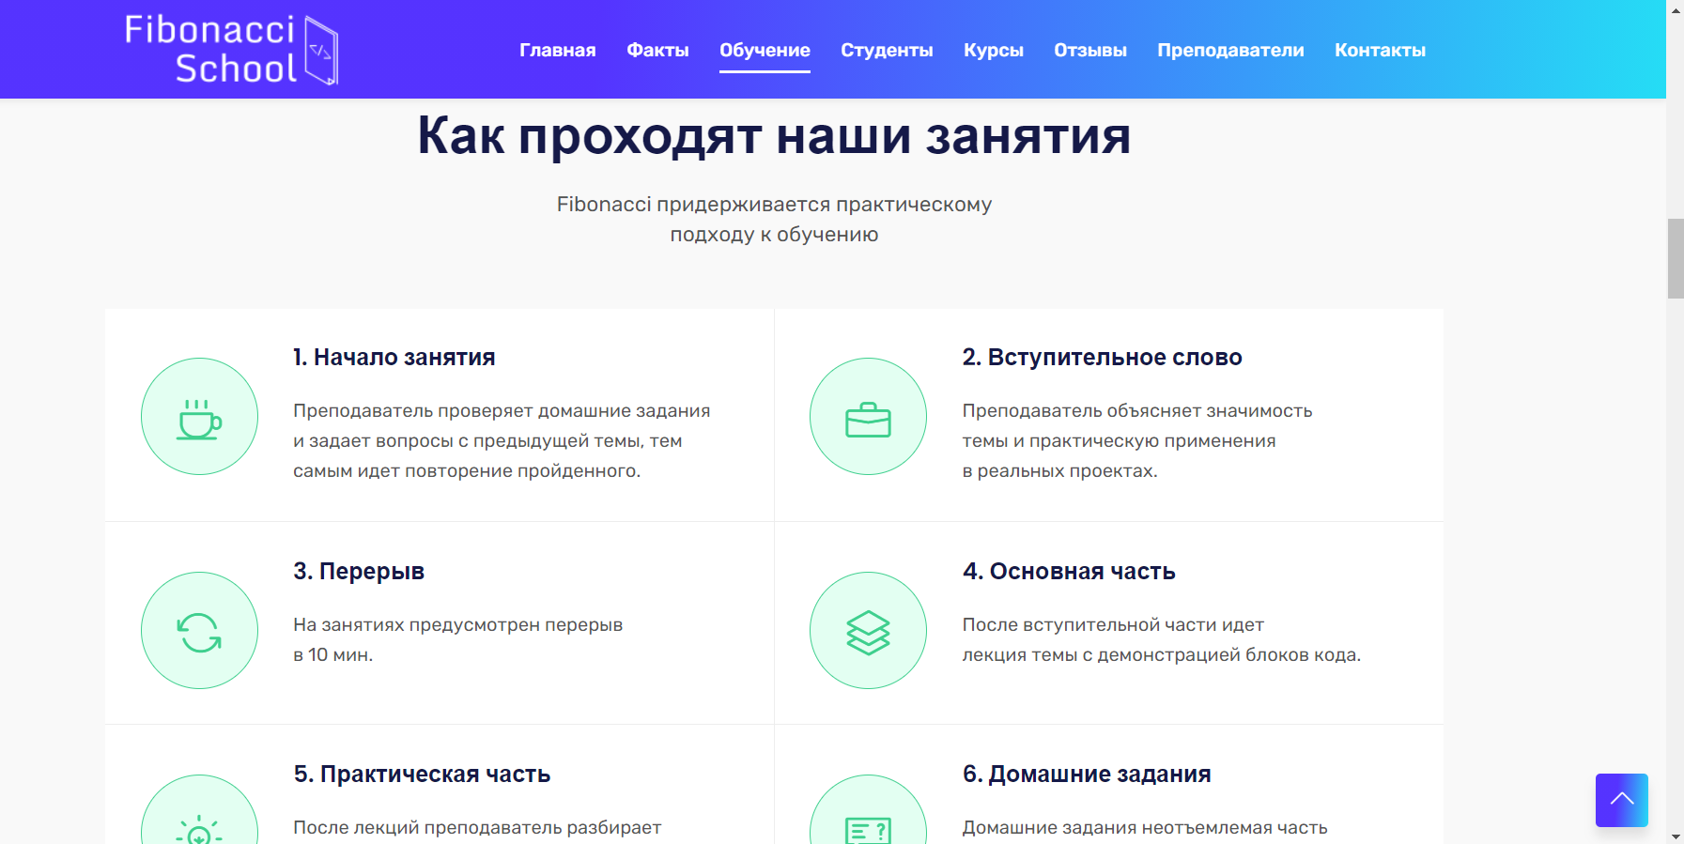

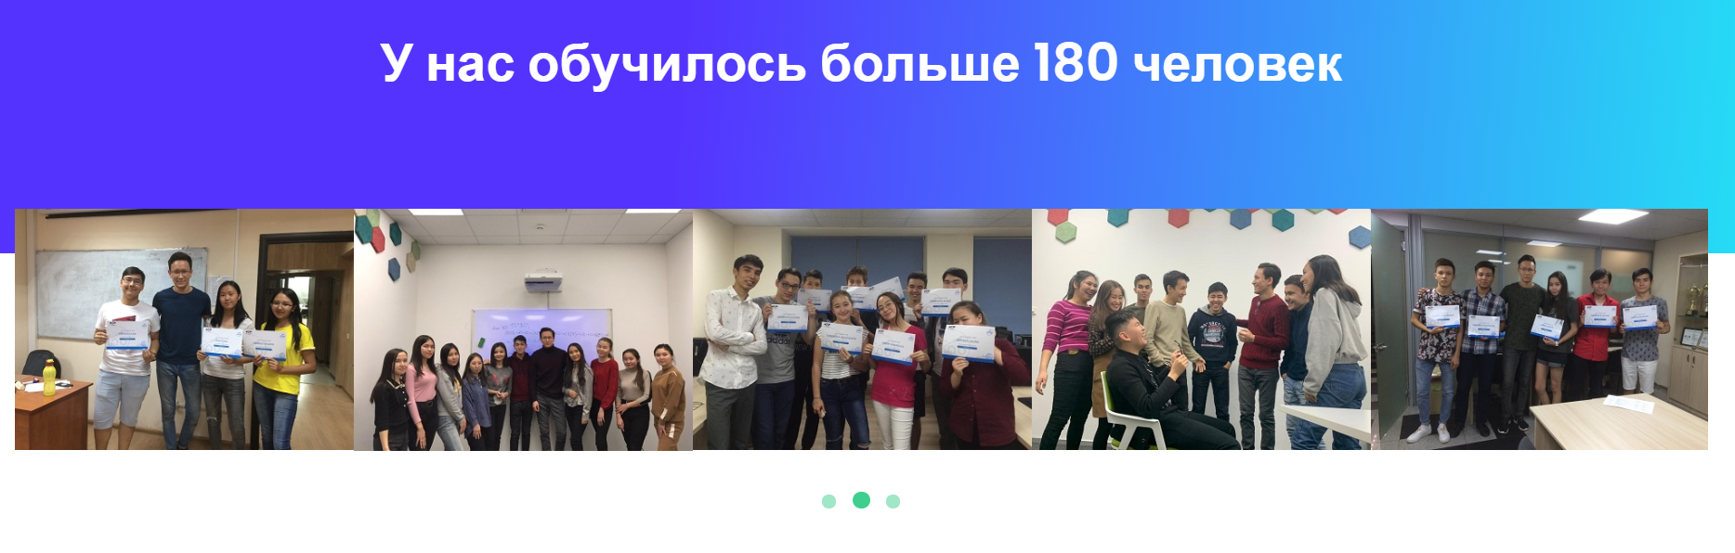

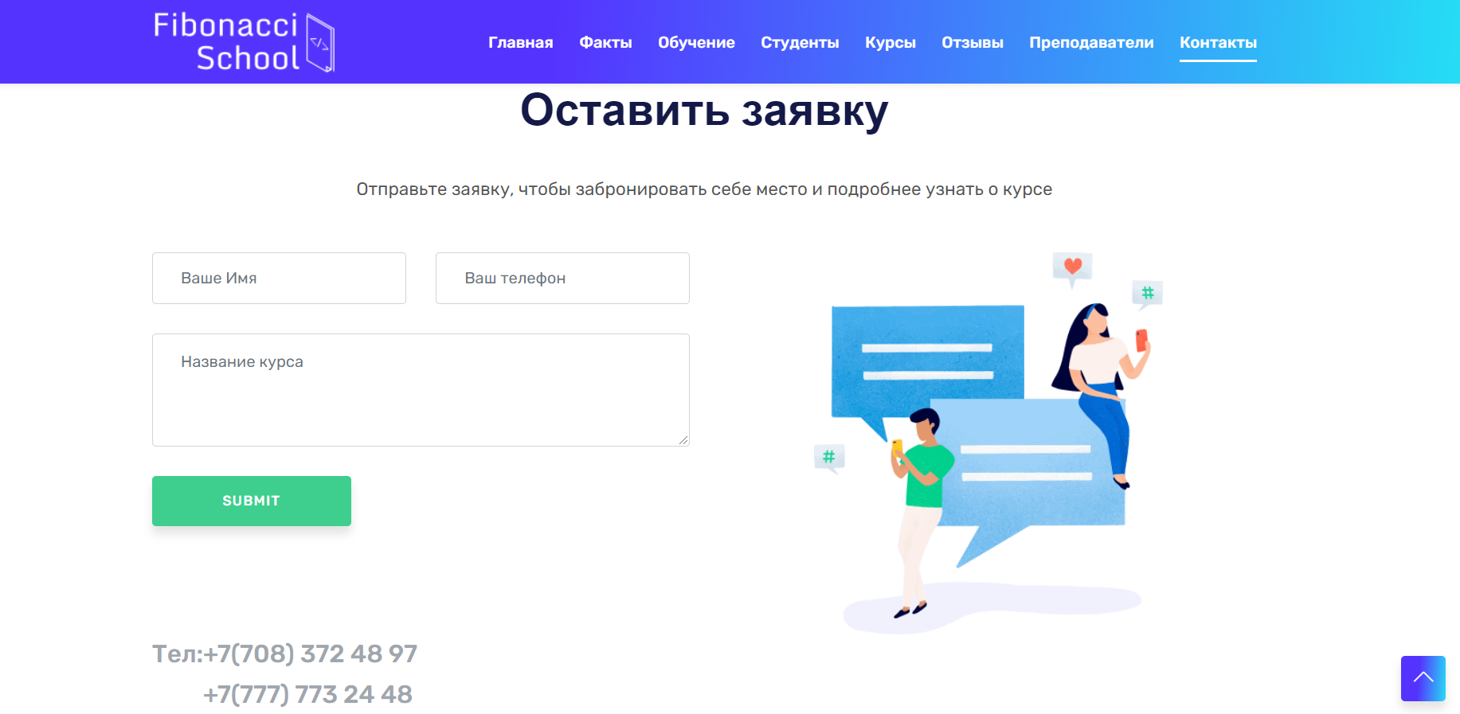

Architecture

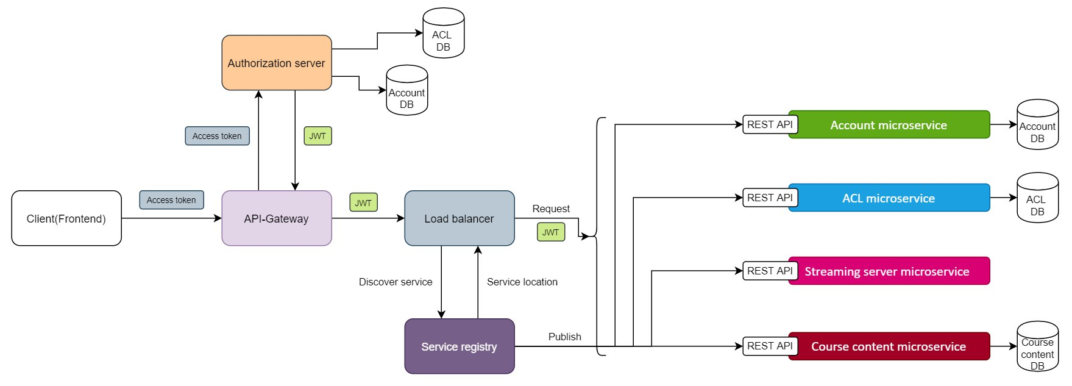

1. The course site-will be the basis, the functionality of the platform will be used here (frontend)

2. Account-here will be all accounts, and everything related to it

3. OAuth-a token will be issued through the service and authentication will be performed

4. ACL-the service will describe the roles where we can assign accounts. Roles will be given access to materials (for example: C++, Java)

5. Streaming server – here you will be given the opportunity to conduct online classes

6. Naming server – it will be possible to interact with other services through the service

Site map

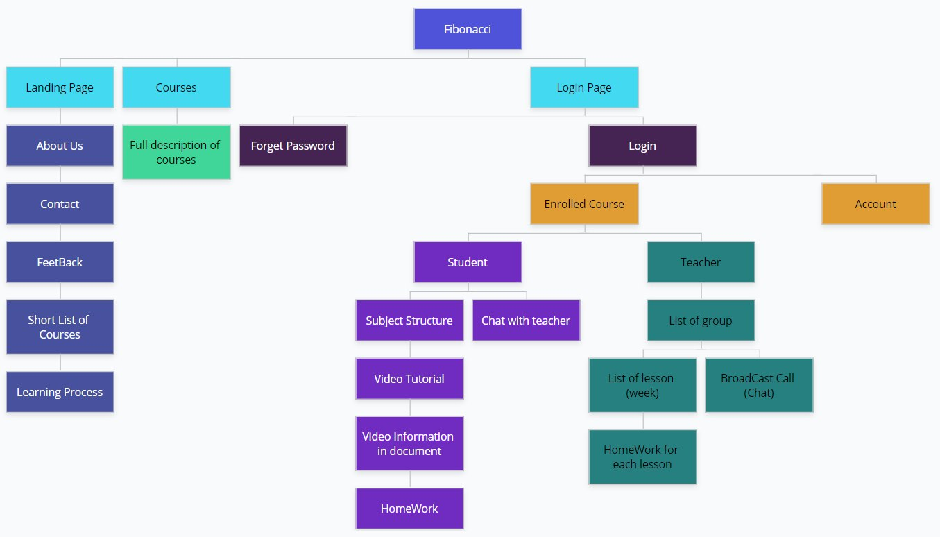

Conclusion

In conclusion, we can see that culture is a key contributor to the success of e-learning. It is important for e-learning course providers to include a study and analysis of the culture of the target student group in the planning stage.

In the end we will try to complete the project during deadline.